

**DRIVER MANAGEMENT system for matours**

Guaranteeing a perfect employer and a perfect driver



to be developed by:

Ernest M’mame

**DRIVER MANAGEMENT SYSTEM FOR MATOURS**

1. **OVERVIEW**

Matours is a Malawian transportation company offering transportation of people and goods. It has a variety of vehicles such as; trucks, lorries, buses, minibuses and taxi’s. They have a lot of drivers to cope with the large number of vehicles.

When the company needs a new driver, the vacancy is spread verbally, and drivers go for interviews upon receiving the message. They are required to bring their drivers licence and previous employers details. Once a driver is hired, driver and associated vehicle details are stored in a book. Reports are produced at the end of the month to determine driver’s salaries. The company totally works in isolation, it just hires, and fires drivers based on their performance while working at Matours.

The current system has many problems;

* Hard to find drivers with the proper skill sets required for a job as the vacancy isn’t well advertised.
* Difficult to keep hired drivers, vehicles and jobs.
* Paper based data storage that has no back up.
* Data sharing and communication to other branches and traveling drivers is difficult.
* They work in isolation to other companies.
* Reports generation is a tedious process as the system is paper based.
* Nearly impossible to research on drivers.

Matours need an online system that;

* improves vacancy sharing
* keeps track of all professional drivers
* Generates driver and job reports
* Stores all drivers, jobs and vehicle details on an online database making data available from anywhere

To solve the problem of working in isolation with other companies and hiring the right driver for a job, the system will be used by all professional drivers and all transportation companies. This will work as stated below;

* Professional drivers will register to the system. They will include; drivers licence, police rap sheet, previous employer details, skillset and job preferences.
* Employers will register to the system as well. They will post jobs together with their preferences.
* The system will match the jobs to possible jobless drivers and will prompt communications between the involved parties using SMS, emails or video chat all via the system.
* The system will have a search function to check all drivers and employers.
* Employers will be able to communicate.
* The employers will be able to communicate with their drivers.
* Employers will be able to download reports produced by the system.

The system will be a well live based web application that is present in many languages accessible with different devices to broaden up the number of people that can access the system.

1. **AIM**

Developing a system that simplifies driver searching and driver management by improving communications and statistical report generation that will aid in finding the best drivers for a job.

1. **OBJECTIVES**
   1. **INVESTIGATING AND ANALYSING THE CURRENT SYSTEM**
      1. Research on how Matours locates and hires new drivers.
      2. Investigating Matours manages drivers and their jobs.
      3. Consider the most popular used languages when communicating.
      4. Research how other similar companies handle driver searching and management.
      5. Gathering user requirements.
   2. **DESIGNING THE SYSTEM**
      1. Selecting case tools that will be useful in the development of the new system.
      2. Designing the web applications interface.
      3. Designing systems functionalities.
      4. Developing the systems database.
   3. **DEVELOPING THE SYSTEM** 
      1. Developing the web applications user interface.
      2. Coding the functionalities of the system.
      3. Developing the applications database.
   4. **TESTING AND IMPLEMENTING THE SYSTEM**
      1. Running various tests on the system
      2. Evaluating if all requirements have been met and specifications have been achieved
      3. Checking all points of failure and success with the developed system
2. **PLAN AND METHODOLOGY**

The system will be developed Using the object-oriented Methodology. This methodology uses the Development Life Cycle (SDLC), MoSCoW prioritisation and UML diagrams. The SDLC is incremental, iterative and both technical and user oriented making sure the right product is developed at the end that does what is required and meets all user requirements.

Below is a table detailing the timeboxes for this system.

|  |  |  |  |
| --- | --- | --- | --- |
| **TASK** | **ACTIVITIES** | **START DATE** | **END DATE** |
| Literature review | * Research on driver management systems. * Investigate benefits of having an online job finding systems. * Look up on online databases and why they are essential. | 1st November 2017 | 15th November 2017 |
| Requirments capture | * Conduct interviews with different staff working at Matours. * Study how the current driver hiring and management works. | 16th November 2017 | 30th November 2017 |
| Requirments Analysis | * Go through collected information and point areas of concern and need of improvement. * Finding best solutions of discovered problems. * Communicating with users on solutions | 1st December 2017 | 20th December 2017 |
| System Design | * Using case tools to produce UML models | 21st December 2017 | 31th December 2017 |
| Implementation | * Developing database * Developing system interface. * Coding functionalities. | 1st January 2018 | 28th February 2018 |
| Testing | * Running various tests on application | 1st March 2018 | 15th March 2018 |
| Production of documentation | * Producing technical and user documentation documents | 16th March 2018 | 16th April 2018 |

* 1. **Gantt Chart**

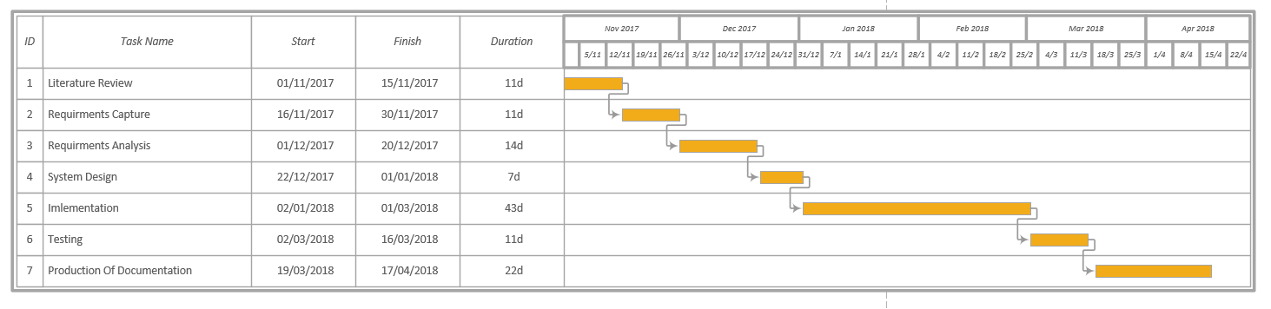

1. **RESCOURCE REQUIRMENT AND TOOLS**

The web application will be developed in HTML, PHP and JavaScript. It will use MySQL for the database. Atom text editor will be used for the coding and WAMP will be used to access the MySQL database. Models will be developed using Star UML to develop the ERD, Class diagram, Use case diagram.

1. **OTHER ISSUES AND CONCIDERATIONS**
   1. **Legal Issues**

* All details provided by the users will be confidential and secured respecting user privacy laws and intellectual property laws.
* The owners of the system are Matours and they will not use this ownership to tilt the system in their favour.
* All data fed to the system will be kept secure abiding to the Data Protection Law.
  1. **Social Issues**
* The system will not be cultural or ethically biased. All users will be able to use the system no matter culture or ethnicity.
  1. **Professional Issues**
* The system will not favour Matours in the hiring of drivers, they just own the system, but it will be used equally by all registered users

1. **REFFERENCES**